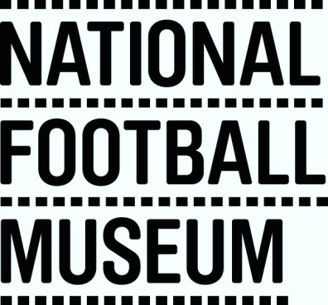

Access Statement for the National Football Museum

This access statement does not contain personal opinions as to our suitability for those with access needs, but aims to accurately describe the facilities and services that we offer all our visitors.

We are a fully interactive, hands on museum with provision made for visitors with disabilities and specific needs.
We want everyone to enjoy their visit to the museum and believe we provide access to all facilities, activities and events.
The museum provides:-
- Automatic door access at the main entrance
- Staffed lift to all floors
- Ramps to all raised areas
- Disabled parking on Todd Street (outside Victoria Station)
- 130+ disabled parking spaces in the nearby NCP’s (Arena, Exchange, Shudehill, High Street)
- Accessible toilets ground floor, levels 1,2 and 4
- Induction loops at the reception, shop and information desks
- Assistance animals permitted (water bowls available from the front desk)
- Wheelchairs on request
- Guided tours upon request
- Familiarisation Guides can be downloaded from the website
- Large print guide available upon request (or can be downloaded from the website).
- Front of House staff have received Visually Impaired & Deaf Awareness training.

