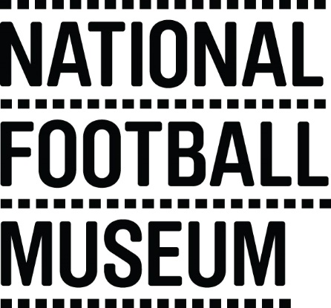 | Volunteering with your family is a unique way to spend time together and share rewarding experiences too.  The National Football Museum exists to explain how and why football has become ‘the people's game', a key part of England's heritage and way of life. It also aims to explain why England is the home of football, the birthplace of the world's most popular sport.  The Museum has a long-term mission, a responsibility to protect football’s heritage and culture for future generations as well as current audiences.  The museum is for everyone, regardless of age, gender, disability, sexuality, religion or any other factor.
Role Title | Family Engagement Volunteers
Responsible To | Front of House Manager
Purpose of Role | Working as a family to provide a level of care that exceeds customer expectations, bringing your team’s passion for football and engaging with visitors to the fore.
Description of Tasks | - Facilitating object handling  - Assisting with visitor enquiries at the information desk  - Engaging with visitors on the galleries  - Assisting with craft activities  - To work within the Volunteer Agreement guidelines and related organisational policies (Child Protection and Health and Safety)
Time Commitment | On-going
Skills/Characteristics Required | - Friendly and welcoming  - Passion for football and history  - Enjoys engaging with people  - Enjoys working as part of a team
Training and Support | Volunteer Families will be provided with a full induction to the volunteer programme; including health and safety and fire evacuation.  Training will be provided in the following areas:  - Introduction to museums  - Customer care  - Disability awareness  - Working safely with children  - Object handling  Specific training will be provided for each task (including guided tours and information desk).
Benefits to Volunteering | - Develop skills and experience  - Become part of a friendly team of like-minded people  - Help to share the National Football Museum’s amazing collection with people from all walks of life  - Indulge your passion for football  - Volunteer as a family
Darren.collingwood@nationalfootballmuseum.com
Volunteer Manager

Contact Information

