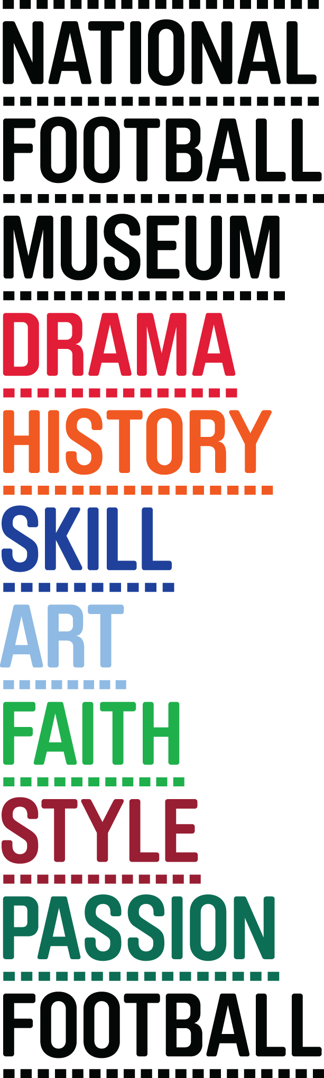
Embargoed until 11am on 07 September 2015

*** PHOTO/FILMING/INTERVIEW OPPORTUNITY ***

WALK OF FAME PLANS REVEALED
FOR THE NATIONAL FOOTBALL MUSEUM

WHAT: Sir Bobby Charlton will be in attendance as plans are unveiled for the first FOOTBALL WALK OF FAME, a permanent ‘free to view’ tribute to the global icons of international football. Among the first to be immortalised will be the members of the 1966 England team as part of the Museum’s 50th anniversary celebrations in Summer 2016.

WHEN: Monday 7th September @ 11am

WHO: 1966 World Cup Winner - Sir Bobby Charlton
Sports artist - Paul Trevillion
UK Walk of Fame attraction founder - David Courtney
Manchester City Council Chief Executive – Sir Howard Bernstein
National Football Museum Director - Kevin Moore

WHERE: SoccerEx - Manchester Central

World’s First Official Walk Of Fame Will Take Pride Of Place At Museum With 66 Squad Among First To Be Honoured Ahead Of The 50th Anniversary Celebrations

Plans were revealed today at Soccerex for the world’s first FOOTBALL WALK OF FAME, a permanent ‘free to view’ tribute to the global icons of international football. Among the first to be immortalised will be the members of the 1966 England team as part of the Museum’s 50th anniversary celebrations in Summer 2016.
The Walk of Fame has been made possible as the result of a collaboration between internationally renowned composer, founder of the UK Walk of Fame cultural attractions David Courtney, ‘Master of Movement’ legendary sports artist and innovator Paul Trevillion and the National Football Museum.

In addition to the 11 English heroes from the 66 team, England manager Sir Alf Ramsey will also be amongst the first names to be inducted alongside Brazilian international Pelé who will receive the first ‘Football Walk of Fame Legend Award’.
Displayed as a trail leading to the entrance of the Museum, the Walk of Fame will feature images of inductees immortalised with stunning iconic Trevillion drawings embedded in brass plaques.

David Courtney says: “This has been a long time dream come true for me as a massive football fan and to be involved in creating a true legacy to the sport I love is beyond all expectations. I am particularly proud that ‘The Football Walk of Fame’ will re-establish our place in history as the ‘birthplace’ of the greatest sport in the world. We are creating a global landmark for the game and one that we envisage will attract football fans from all corners of the globe.”

Paul Trevillion is quoted as saying: “The National Football Museum which embraces the history and the future of football is the perfect location for the Football Walk of Fame which allows the millions of football fans worldwide to walk in the footsteps of the greatest players to grace the game. I am deeply honoured that my football art will help to bring the FWF to life.”

Dr Kevin Moore, Director of the National Football Museum, adds; “We’re delighted to introduce the Football Walk of Fame in Manchester to the world. This is an excellent way for us to honour and celebrate some of the greatest International names in the game, and we’re looking forward to working with the unique talents of Paul Trevillion and David Courtney on this prestigious project. This is going to be a wonderful attraction for football fans, families and tourists visiting the City.
...............................................................................................................

- END -
For further information, please contact Joe Murgatroyd or Cain Wilkes at Brazen PR on 0161 923 4994 or at footballmuseum@brazenpr.com
Notes to Editor:
DAVID COURTNEY
Grammy nominated composer & record producer David Courtney has written & worked with some the biggest names in music during his 50 year career including, Roger Daltrey, Sir Paul McCartney, Pink Floyd guitarist David Gilmour, discovered Leo Sayer and penned hits including ‘The show must go on’ ‘One Man Band’ & ‘Giving it all away’ and has sold in excess of 33 million records world-wide

PAUL TREVILLION
Paul Trevillion known as the ‘Master of Movement’ is legendary sports artist and innovator described as a maverick by many, whose credits include creator/artist of the longest running football strip in history ‘You are the Ref’, the man who successfully introduced ‘comic art realism to ‘Roy of the Rovers’ in the 1960’s and the man whose innovations have changed sport over the past 60 years.

THE NATIONAL FOOTBALL MUSEUM
The National Football Museum was established and its collection acquired thanks to £9.3m investment by the Heritage Lottery Fund.
The National Football Museum is a registered charity overseen by a board of trustees, and also counts notable names amongst its honorary positions, including Museum President Sir Bobby Charlton, Museum Vice Presidents Sir Alex Ferguson, Sir Trevor Brooking and Sir Geoff Hurst, plus Museum Special Ambassador Mark Lawrenson.
The museum also provides a permanent home for its nationally-recognised Hall of Fame, with new legends being inducted in a prestigious awards ceremony every year.
Entrance is free. To enhance the Museum experience, there are some additional exclusive paid-for interactive exhibits ‘Football Plus+’ to help ensure that visitors enjoy one of the best days out in the city.
Opening Times:
Monday-Saturday 10am – 5pm
Sunday 11am – 5pm
Open Every Day excluding Christmas Eve, Christmas day, Boxing Day and New Year’s Day
The venue is fully accessible for wheelchair access
www.nationalfootballmuseum.com
Mirrorpix is the Official Image Partner of the National Football Museum

ABOUT SOCCEREX

Established in 1995, Soccerex is the leading provider of business events for the global football community. Bringing together key industry decision makers from the world of football, Soccerex provides a unique commercial environment where delegates can benefit from exclusive business opportunities, networking and bespoke educational content. Since the first event in 1996, Soccerex has hosted over 37 events across five continents. The Soccerex portfolio includes an annual Global Convention complimented by continental Forums and regional Seminars.

