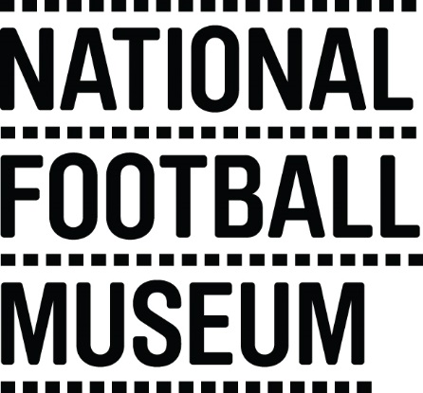 | The National Football Museum exists to explain how and why football has become ‘the people's game', a key part of England's heritage and way of life. It also aims to explain why England is the home of football, the birthplace of the world's most popular sport.  The Museum has a long-term mission, a responsibility to protect football’s heritage and culture for future generations as well as current audiences.  The Museum is for everyone, regardless of age, gender, disability, sexuality, religion or any other factor.
Role Title | Visitor Engagement Volunteer
Responsible To | Front of House Manager
Purpose of Role | To provide additional services that enhance the visitor experience at the National Football Museum, providing a level of care that exceeds customer expectations.
Description of Tasks | - Guided tours of Museum galleries  - Facilitating object handling  - Information desk assisting with visitor enquiries  - Presence in galleries to engage with visitors  - To work within the Volunteer Agreement guidelines and related organisational policies (Child Protection and Health and Safety)
Time Commitment | On-going (minimum six month’s commitment). Minimum attendance of twice per month.
Skills/Characteristics Required | - Friendly and welcoming nature  - Passion for football and history  - Enjoys engaging with people
Training and Support | Volunteers will be provided with a full induction to the volunteer programme including health and safety and fire evacuation.  Training will be provided in the following areas:  - Introduction to Museums  - Customer Care  - Disability Awareness  - Working Safely with Children  - Object handling  Specific training will be provided for each task (including guided tours and information desk).
Benefits to Volunteering | - Develop skills and experience to enhance your CV  - Become part of a friendly team of like-minded people  - Help to share the national Football Museum’s amazing collection with people from all walks of life  - Indulge in your passion for football
How to apply | If you would like to be a volunteer please contact: Darren.collingwood@nationalfootballmuseum.com Volunteer Coordinator, expressing an interest in this position

