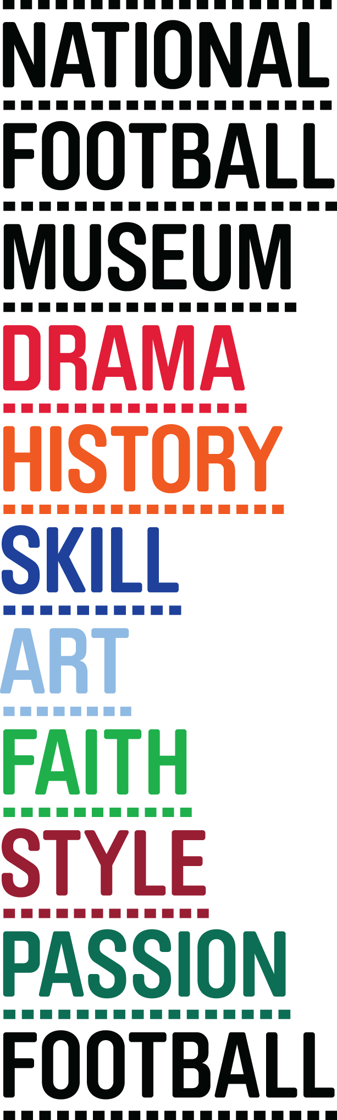
MATTHEWS FINAL WINNERS MEDAL GOES ON DISPLAY AT THE NATIONAL FOOTBALL MUSEUM

THE DRIBBLE WIZARD’S FINEST PERFORMANCE REMEMBERED

THE 1953 FA Cup winners medal of footballing legend, Sir Stanley Matthews is set to go on display at the National Football Museum.

Known as the “Matthews Final”, the 1953 FA Cup Final saw a standout performance from the winger as he helped claw Blackpool back from 3-1 down to take a dramatic 4-3 victory against Bolton Wanderers.

The famous final was played in front of a 100,000 capacity crowd at Wembley Stadium as well as millions more at home as it became the first FA Cup Final to be televised live.

The victory put an end to the player’s heartache in the competition after being on the losing side at both the 1948 and 1951 Finals.

The nine carat gold medal, presented to him by Queen Elizabeth II on the year of her coronation, will go on display on 1st February to coincide with what would have been the player’s 100th birthday.

The ‘Matthews Final’ has gone down in history as one of the most memorable matches at Wembley Stadium and as one of the greatest all-time individual performances from Matthews that featured his on-the-ball wizardry and trademark jinks.

Matthews, who at the time had been a professional footballer for 21 years, even outshined Blackpool teammate Stan Mortensen who was the first player to score a hat-trick in a Wembley FA Cup Final – a remarkable feat that still stands 62 years later.

Kevin Moore, Director at the National Football Museum said: “Following the recent drama in the FA Cup, this incredible medal is a timely reminder of the competition’s magic and unrivalled history.

“We’re delighted to add the medal to our collection and give visitors the chance to discover the incredible story behind it. Sir Stanley Matthews is a true sporting hero and the 1953 FA Cup Final was his finest hour.”

The medal is on loan to the museum after its sale at Graham Budd Auctions. Previously owned by Nick Hancock, the medal was sold to a private collector in November 2014.

The medal will take pride of place in the National Football Museum alongside Matthews’s shirt, shorts and socks from the same match.

-ENDS-

For more information and media enquiries please contact Tom or Joe at Brazen on E:footballmuseum@brazenpr.com T: 0161 923 4994
The National Football Museum Registered Charity Number: 1050792
Website: www.nationalfootballmuseum.com
Notes to Editors:
The National Football Museum’s current exhibition The Greater Game: Football and the First World War, has been made possible thanks to funding from the Heritage Lottery Fund. www.hlf.org.uk. This exhibition forms part of the First World War Centenary Partnership, led by Imperial War Museums. www.1914.org.

The National Football Museum was established and its collection acquired thanks to £9.3m investment by the Heritage Lottery Fund.
The National Football Museum is a registered charity overseen by a board of trustees, and also counts notable names amongst its honorary positions, including Museum President Sir Bobby Charlton, Museum Vice Presidents Sir Alex Ferguson, Sir Trevor Brooking and Sir Geoff Hurst, plus Museum Special Ambassador Mark Lawrenson.
The museum also provides a permanent home for its nationally-recognised Hall of Fame, with new legends being inducted in a prestigious awards ceremony every year.
Entrance is free. To enhance the Museum experience, there are some additional exclusive paid-for interactive exhibits ‘Football Plus+’ to help ensure that visitors enjoy one of the best days out in the city.
Opening Times:
Monday-Saturday 10am – 5pm
Sunday 11am – 5pm
Open Every Day excluding Christmas Eve, Christmas day, Boxing Day, New Year’s Day and Easter Sunday
The venue is fully accessible for wheelchair access
ERDF in the Northwest
The European Regional Development Fund (ERDF) is making a real difference to people and businesses in the North West. With €755 million to invest between 2007 and 2013, ERDF is enhancing the competitiveness of the region’s economy by supporting growth in enterprise and employment.
ERDF in the North West is managed by the Department for Communities and Local Government – for further information visit www.communities.gov.uk/erdf.
Mirrorpix is the Official Image Partner of the National Football Museum

