**NATIONAL FOOTBALL MUSEUM  
JOB DESCRIPTION**

**DEPARTMENT:** Collections

**JOB TITLE:** Collections Support Officer

**REPORTS TO:** Collections Manager

**RESPONSIBLE FOR**: Volunteers, project and placement posts as required

**OVERALL PURPOSE OF THE POST:**

Responsible for supporting all aspects of the development and management of the Museum’s collections and meeting the public’s need to access the collections through enquiries, interpretation and education services.

**KEY RESPONSIBILITIES**

* Managing day-to-day collections activities and correspondence with lenders and donors
* Supporting the Collections team with Collections Management including cataloguing, accessioning, environmental monitoring, object marking, digitising, object handling and storage according to SPECTRUM standards
* Loan management for permanent and temporary exhibitions, including loan documentation and transport of loans
* Making changes and upgrades to the existing displays in the Museum and updating graphics
* Contributing to a programme of temporary displays and events at the Museum and at other appropriate locations as well as couriering objects to external events
* answering enquiries from researchers and members of the public, giving talks/tours and advising on the development of educational resources based on the collections
* Assisting updating the on-line collections database, Collections News/blog and online exhibitions
* Liaising with the Marketing Team to promote the collection and new acquisitions

Essential Qualifications

1. Educated to degree level

Experience

1. Experience of working with collections in a paid or unpaid capacity
2. Collections Management including collections databases, documentation and loan procedures and digital images
3. Object handling and preparation of exhibitions

Essential Knowledge and Skills

1. Effective team player

Excellent interpersonal and communication skills

1. Excellent organisational skills and attention to detail
2. Budget management
3. Sound judgement and effective decision making skills
4. Drive and determination to achieve results
5. Self-starting, positive, enthusiastic and energetic with good time management skills
6. IT skills including spreadsheets, databases and electronic imaging
7. Ability to interpret collections and work with external partners

**Contract Type:**

Fixed term to end of September 2018

Part Time 15.00 hours over 2 days

Based at NFM Manchester

**Salary:**

£18,360 pro rata



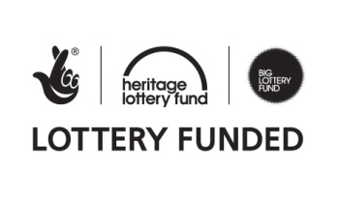MCC Logo FINAL Black.tif