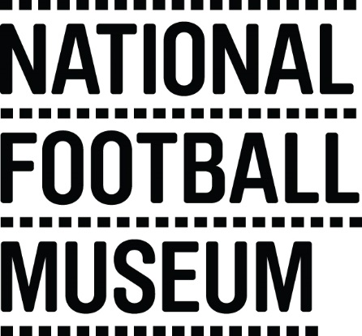 | The museum is currently looking to develop a pool of education facilitators to help deliver the learning team’s excellent schools programme. This opportunity is ideal for someone with experience in teaching/youth work and an enthusiasm for history looking to gain experience working within museum education and heritage learning.  The National Football Museum exists to explain how and why football has become ‘the people's game', a key part of England's heritage and way of life. It also aims to explain why England is the home of football, the birthplace of the world's most popular sport.  The Museum has a long-term mission, a responsibility to protect football’s heritage and culture for future generations as well as current audiences.  The museum is for everyone, regardless of age, gender, disability, sexuality, religion or any other factor.
Role Title | Volunteer Education Practitioner
Responsible To | Learning & Communities Coordinator
Purpose of Role | Working with the learning team to help deliver the museum’s schools programme. Welcoming schools to the museum, facilitating sessions from KS1 – KS5 level and liaising with Front of House team to ensure school groups enjoy their visit.
Description of Tasks | - Welcome school visits  - Engaging with teachers and students on the galleries  - Assist and lead on delivery of school sessions  - To work within the Volunteer Agreement guidelines and related organisational policies (Child Protection and Health and Safety)
Time Commitment | On-going
Skills/Characteristics Required | - Experience working with young people  - Experience delivering workshops to a school audience  - Knowledge of working within a classroom and skill in leading and encouraging pupils  - Passion for football and social history  - Enthusiasm for heritage learning
Training and Support | Volunteer Education Practitioners will be provided with a full induction to the volunteer programme; including health and safety and fire evacuation.  Training will be provided in the following areas:  - Introduction to museums  - Learning and session delivery  - Disability awareness  - Working safely with children
Benefits to Volunteering | - Gain experience working within museum learning  - Become part of a friendly team of like-minded people  - Help to share the National Football Museum’s amazing collection with school and community groups
Contact Information | Volunteering@nationalfootballmuseum.com

