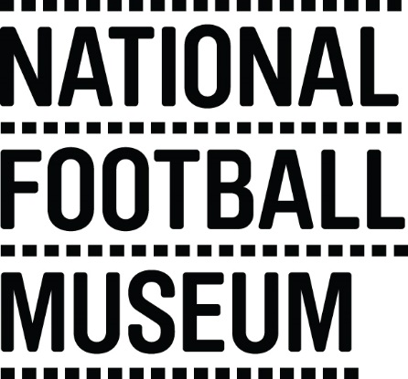 | The National Football Museum exists to explain how and why football has become ‘the people's game', a key part of England's heritage and way of life. It also aims to explain why England is the home of football, the birthplace of the world's most popular sport.  The Museum has a long-term mission, a responsibility to protect football’s heritage and culture for future generations as well as current audiences.  The museum is for everyone, regardless of age, gender, disability, sexuality, religion or any other factor.
Role Title | Volunteer Women’s Football Workshop Practitioner
Responsible To | Learning & Communities Coordinator
Purpose of Role | Support delivery of an object based workshop around the social history of women’s football. To work alongside Museum staff to set up the activity as well as to engage with adult learners and family learners to encourage discussion and learning. Activities may take place at NFM or as outreach in community venues
Description of Tasks | - Work with other volunteers and staff to set up activity  - Support collections linked learning using objects  - Support conversation and facilitate learning about the social history of the women’s game  - To work within the Volunteer Agreement guidelines and related organisational policies (Child Protection and Health and Safety)
Time Commitment | Ad hoc depending on session booking
Skills/Characteristics Required | - Experience working with adults and families in an educational context  - Experience delivering workshops  - Passion for football and social history  - Enthusiasm for heritage learning and creativity
Training and Support | Volunteers will be trained in object handling skills and the history of women’s football. Volunteers will also receive a full induction to the volunteer programme; including health and safety and fire evacuation  Training will be provided in the following areas:  - Introduction to museums  - Learning and session delivery  - Disability awareness  - Working safely with museum visitors and vulnerable adults
Benefits to Volunteering | - Gain experience working within museum learning  - Become part of a friendly team of like-minded people  - Help to share the National Football Museum’s amazing collection with community groups
Contact Information | volunteering@nationalfootballmuseum.com

