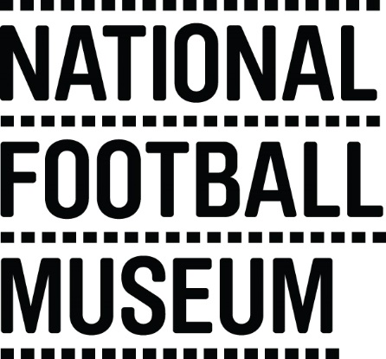 | The museum is currently looking to develop a pool of education facilitators to help deliver the learning team’s excellent schools programme. This opportunity is ideal for someone with experience in teaching/youth work and an enthusiasm for history looking to gain experience working within museum education and heritage learning.  The National Football Museum exists to explain how and why football has become ‘the people's game', a key part of England's heritage and way of life. It also aims to explain why England is the home of football, the birthplace of the world's most popular sport.  The Museum has a long-term mission, a responsibility to protect football’s heritage and culture for future generations as well as current audiences.  The museum is for everyone, regardless of age, gender, disability, sexuality, religion or any other factor.
Role Title | Volunteer First Division Delivery Assistant
Responsible To | People & Communities Coordinator – Adults and Families
Purpose of Role | Working with People & Communities Officer to assist in the delivery of maths lessons to adult learners with a variety of needs. The lessons are delivered as outreach in the local community.
Description of Tasks | - Assist in the set up and set down of activities  - Assist in the practical activities using football to inspire maths  - Provide encouragement and support to learners where needed  - To support facilitator in documenting and evaluating lessons
Time Commitment | Each lesson will require 4 hours volunteer time. The initial series of lessons will run from November to end of December. There are likely to be more similar opportunities in the near future.
Skills/Characteristics Required | - Experience of adult education  - Understanding of learning in a cultural organisation  - Excellent communication skills  - Understanding of Functional Skills Level 1 and 2 maths  - Good organisational skills
Training and Support | - Volunteers will be shown the activities and given the opportunity to have a go themselves.  - Volunteers will be shown how to engage learners with specific resources and activities.
Benefits to Volunteering | - Gain experience working within museum and adult learning  - Become part of a friendly team of like-minded people  - Help to share the National Football Museum’s amazing collection with community groups
Contact Information | Darren.collingwood@nationalfootballmuseum.com  Volunteer Programme Manager

