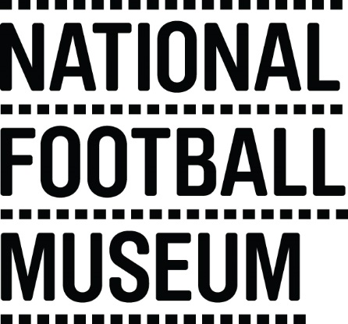 | The museum is currently looking to develop a pool of education facilitators to help deliver the learning team’s excellent schools programme. This opportunity is ideal for someone with experience in teaching/youth work and an enthusiasm for history looking to gain experience working within museum education and heritage learning.  The National Football Museum exists to explain how and why football has become ‘the people's game', a key part of England's heritage and way of life. It also aims to explain why England is the home of football, the birthplace of the world's most popular sport.  The Museum has a long-term mission, a responsibility to protect football’s heritage and culture for future generations as well as current audiences.  The museum is for everyone, regardless of age, gender, disability, sexuality, religion or any other factor.
Role Title | Volunteer First Division Resource packer
Responsible To | People & Communities Coordinator – Adults and Families
Purpose of Role | Working with People & Communities Officer to organise and prepare First Division maths resources
Description of Tasks | - Work with other volunteers to organise resources  - Carefully pack resources in to packaging taking care to ensure the correct resource are incorporated
Time Commitment | 3 x 3hours
Skills/Characteristics Required | - Good organisational skills  - Methodical working skills  - Good communication skills
Training and Support | - Volunteers will be shown precisely which resources and how many are to be included in the packaging.  - Volunteers will be shown how to physically arrange resources
Benefits to Volunteering | - Gain experience working within museum learning  - Become part of a friendly team of like-minded people  - Help to share the National Football Museum’s amazing collection with community groups
Contact Information | Darren.collingwood@nationalfootballmuseum.com  Volunteer Programme Manager

