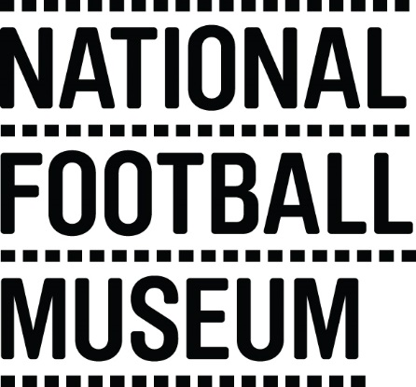 | The National Football Museum exists to explain how and why football has become ‘the people's game', a key part of England's heritage and way of life. It also aims to explain why England is the home of football, the birthplace of the world's most popular sport.  The Museum has a long-term mission, a responsibility to protect football’s heritage and culture for future generations as well as current audiences.  The Museum is for everyone, regardless of age, gender, disability, sexuality, religion or any other factor.
Role Title | Event Volunteer (evenings)
Responsible To | Front of House Manager , Duty Managers
Purpose of Role | To provide additional services that enhance the visitor experience at the National Football Museum, providing a level of care that exceeds customer expectations during evening events
Description of Tasks | - Engaging with visitors on the galleries during events  - Assisting with visitor enquiries  - Assisting with set up / Take down of events  - Assist visitors with the use of the Football + Interactives  - To work within the Volunteer Agreement guidelines and related organisational policies (Child Protection and Health and Safety)
Time Commitment | On-going as and when required  Shifts will be 5.30pm – 8.30pm
Skills/Characteristics Required | - Friendly and welcoming nature  - Passion for football and history  - Enjoys engaging with people
Training and Support | Volunteers will be provided with a full induction to the volunteer programme including health and safety and fire evacuation.  Training will be provided in the following areas:  - Introduction to Museums  - Customer Care  - Disability Awareness  - Working Safely with Children  - Object handling  Specific training will be provided for each task (including guided tours and information desk).
Benefits to Volunteering | - Develop skills and experience to enhance your CV  - Become part of a friendly team of like-minded people  - Help to share the national Football Museum’s amazing collection with people from all walks of life  - Indulge in your passion for football
Contact Information | Volunteering@nationalfootballmusuem.com

