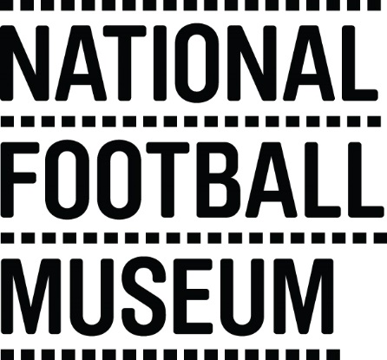 | The National Football Museum exists to explain how and why football has become ‘the people's game', a key part of England's heritage and way of life. It also aims to explain why England is the home of football, the birthplace of the world's most popular sport.  The Museum has a long-term mission, a responsibility to protect football’s heritage and culture for future generations as well as current audiences.  The Museum is for everyone, regardless of age, gender, disability, sexuality, religion or any other factor.
Role Title | Help Desk / Reception Volunteer
Responsible To | Volunteer and Participation Manager
Purpose of Role | To provide additional services that enhance the visitor experience at the National Football Museum, providing a level of care that exceeds customer expectations.
Description of Tasks | - Welcoming visitors, engaging and providing information about the Museum and its collection;  - Assisting on the helpdesk  - Answering a variety of telephone queries  - To work within the Volunteer Agreement guidelines and related organisational policies (Child Protection and Health and Safety)
Time Commitment | One shift on one day per week, on an ongoing basis. Shifts are either 10.30am to 1.30pm or 1.30pm to 4.30pm, Mondays to Sundays.
Skills/Characteristics Required | - Friendly and welcoming nature  - Passion for football and history  - Enjoys engaging with people  - Experience of handling telephone calls  - Able to multitask  - Basic IT skills required
Training and Support | Volunteers will be provided with a full induction to the volunteer programme including health and safety and fire evacuation.  Training will be provided in the following areas:  - Telephone skills  - Customer Care  - Disability Awareness  - Mapping Manchester  Specific training will be provided for each task (e.g. donations collections and information desk).
Benefits to Volunteering | - Develop skills and experience to enhance your CV  - Become part of a friendly team of like-minded people  - Help to share the National Football Museum’s amazing collection with people from all walks of life  - Be part of the Museum’s journey moving forward
Contact Information | volunteering@nationalfootballmuseum.com

