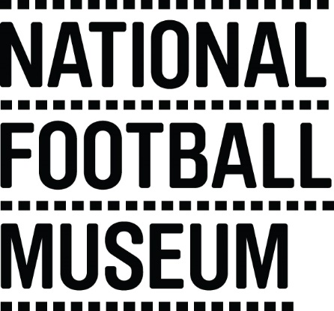 | The National Football Museum exists to explain how and why football has become ‘the people's game', a key part of England's heritage and way of life. It also aims to explain why England is the home of football, the birthplace of the world's most popular sport.  The Museum has a long-term mission, a responsibility to protect football’s heritage and culture for future generations as well as current audiences.  The Museum is for everyone, regardless of age, gender, disability, sexuality, religion or any other factor.
Role Title | Football Skills Volunteer
Responsible To | Front of House Manager
Purpose of Role | To provide soccer skills sessions to enhance the visitor experience at the National Football Museum, providing a level of care that exceeds customer expectations.
Description of Tasks | - Deliver thirty-minute soccer skill sessions to young people  - Develop content for the sessions to be delivered  - Set up the area for the sessions in advance  - Coaching young people through a fun and engaging environment  - Engage with a wide range of skills and abilities  - To work within the Volunteer Agreement guidelines and related organisational policies (Child Protection and Health and Safety)
Time Commitment | Shifts are ongoing on Saturday’s and Sunday’s and weekdays during school holidays
Skills/Characteristics Required | - Friendly and welcoming nature  - Passion for football  - Enjoys engaging with people  - Must have FA Level 1 coaching qualification  - Able to deliver a confident and fun soccer skills session  - Able to plan and develop football skills content
Training and Support | Volunteers will be provided with a full induction to the volunteer programme including health and safety and fire evacuation.  Training will be provided in the following areas:  - Customer Care  - Disability Awareness  - Working with young people  Specific training will be provided for each task (e.g. donations collections and information desk).
Benefits to Volunteering | - Develop skills and experience to enhance your CV  - Become part of a friendly team of like-minded people  - Help to share the National Football Museum’s amazing collection with people from all walks of life  - Be part of the Museum’s journey moving forward
Contact Information | volunteering@nationalfootballmuseum.com

