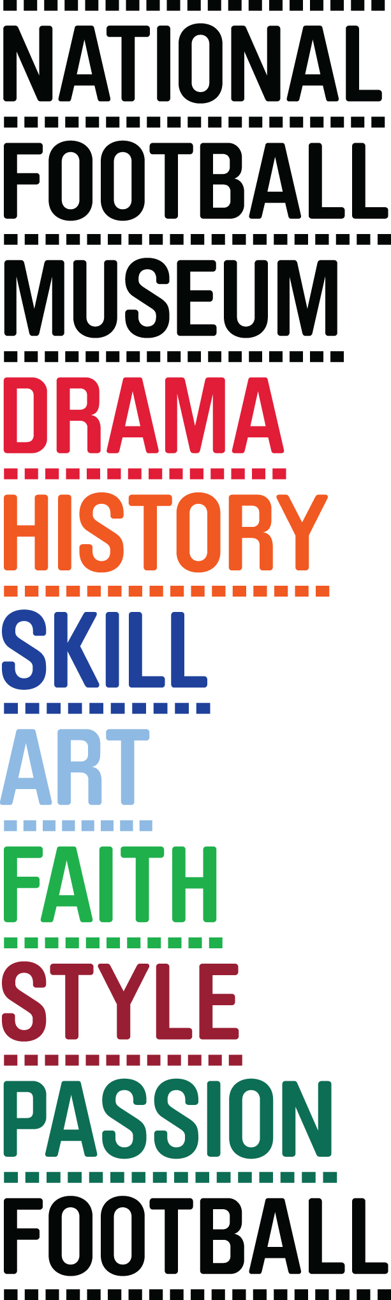
PRESS RELEASE
May ‘15
NATIONAL FOOTBALL MUSEUM SHORTLISTED FOR EUROPEAN MUSEUM OF THE YEAR

This week sees the culmination of the competition for European Museum of the Year, with Manchester’s National Football Museum one of only three British venues included in the shortlist.

From hundreds of entries, the judging panel had the arduous task of whittling them down to just 42 to represent the best in European arts and culture

The panel visited the museum last year to be given a private guided tour around the greatest collection of footballing memorabilia in the world.

Over one and a quarter million people have visited the museum since it moved to Manchester in 2012.

Kevin Moore, Director at the National Football Museum said “We are absolutely thrilled that the museum has been shortlisted for this prestigious award.

“It’s a competitive field but it’s great that our collection has been recognised in this way.

The two other nominees in the U.K are Mary Rose Museum in Portsmouth and Titanic Belfast, Belfast.

The winners will be announced at the award ceremony closing the Annual Assembly of the European Museum Forum, which takes place on 13th – 16th May 2015 in Glasgow. For a full list of nominees see www.europeanmuseumforum.info/

- ENDS -
For more information and media enquiries please contact Joe or Natalie at Brazen PR on E:footballmuseum@brazenpr.com T: 0161 923 4994
The National Football Museum Registered Charity Number: 1050792
Website: www.nationalfootballmuseum.com
Notes to Editors:
The National Football Museum was established and its collection acquired thanks to £9.3m investment by the Heritage Lottery Fund.
The National Football Museum is a registered charity overseen by a board of trustees, and also counts notable names amongst its honorary positions, including Museum President Sir Bobby Charlton, Museum Vice Presidents Sir Alex Ferguson, Sir Trevor Brooking and Sir Geoff Hurst, plus Museum Special Ambassador Mark Lawrenson.
The museum also provides a permanent home for its nationally recognised Hall of Fame, with new legends being inducted in a prestigious awards ceremony every year.
Entrance is free. To enhance the Museum experience, there are some additional exclusive paid-for interactive exhibits ‘Football Plus+’ to help ensure that visitors enjoy one of the best days out in the city.
Opening Times:
Monday-Saturday 10am – 5pm
Sunday 11am – 5pm
Open Every Day excluding Christmas Eve, Christmas day, Boxing Day, New Year’s Day and Easter Sunday
The venue is fully accessible for wheelchair access
ERDF in the Northwest
The European Regional Development Fund (ERDF) is making a real difference to people and businesses in the North West. With €755 million to invest between 2007 and 2013, ERDF is enhancing the competitiveness of the region’s economy by supporting growth in enterprise and employment.
ERDF in the North West is managed by the Department for Communities and Local Government – for further information visit www.communities.gov.uk/erdf.
Mirrorpix is the Official Image Partner of the National Football Museum

