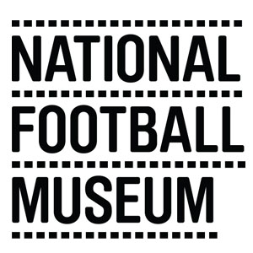
Filming and Photography Rate Card

Photography Hourly Rate 9.30 – 16.00 hours

Commercial | Charities & Education
£175 + VAT per hour | £140 + VAT per hour

Filming Day Rate 9.30 – 16.00 hours

TV/Corporate/Non Feature Films |  | Charities & Education
Crew Size up to 6 | £200 + VAT per hour | £175 + VAT per hour
7 – 15 | £350 + VAT per hour | £300 + VAT per hour
Over 15 | Upon negotiation | Upon negotiation
Large Scale Filming / Feature Films
Upon negotiation

Additional Costs 9.30 – 16.00 hours

Curator time (eg research/interview/object handling and removal) | £75 + VAT per hour
Technical support (eg adjustment of sound or light levels / visuals on digital screen) | £50 + VAT per hour

After Hours Filming & Photography: Due to Covid19 restrictions we regret that we can’t currently offer after hours filming.
Cancellation: In the event that filming or photography is cancelled with more than two working days notice, a cancellation fee will be charged of 50% of the location fee, plus any curatorial or technical support that has already been utilised. In the event that filming or photography is cancelled within two working days or less the full fee will be charged plus any curatorial or technical support utilised.
Over running: Filming or photography which runs over the original agreed period will be charged by the hour with a minimum of one hour’s charge. Due to current circumstances no film crews will be allowed into the museum after 5pm.

