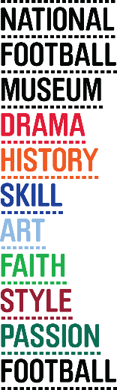
‘Khaki Cup Final’ Remembered at National Football Museum
- Centenary of the only wartime FA Cup Final this weekend
- Game at Old Trafford marked the end of professional football for 4 years
- 50,000 crowd was already mostly in uniform: many would soon be in the trenches
- Sheffield United beat Chelsea 3-0
- Game features in exhibition ‘The Greater Game: Football & The First World War’

Release date: 21 April 2015
This week marks the centenary of one of football’s most significant and controversial Cup Finals; the ‘Khaki Cup Final’, played on 24 April, 1915.
The only FA Cup Final to be played during wartime marked the end of a season that had seen football and its fans used and targeted for propaganda, as the full extent of World War One was realised by the British public.
The game, played at Old Trafford, was won 3-0 by Sheffield United against Chelsea. But it was the overwhelming presence of military uniform in the 50,000 crowd that was to be the defining characteristic of a game which marked the end of competitive football in England for over 4 years.
The game is one of the key moments in The Greater Game: Football & The First World War, an exhibition at the National Football Museum which tells the story of fans, players and the game itself during the bloody conflict.
Head of Creative Programmes at the museum, Andy Pearce, explains more about the mood and significance of the game. “Football fans and players had been targeted for recruitment to the military since the start of the season. By the time of the cup final there is a sense that the game really is up.
The crowd is largely from the Manchester area, with many already in military uniform, who are either on leave or in training. Many had signed up as part of ‘Pals’ battalions.’”
The game itself was played at Old Trafford as the regular FA Cup final venue at the Crystal Palace had already been requisitioned for military training, and travel restrictions in the capital made an alternative London venue impractical.
Collections Officer Dr Alexander Jackson explains further about the crowd; “At the end of the game, Lord Derby, who was there to present the trophy, addressed the fans suggesting that, with the Cup now won, the time for games was over, and that anyone not yet in uniform should now sign up to do his duty.
“Anti-football feeling in many sections of the press had reached its peak before the game. Within months many of the crowd, and the players, would be in the trenches.”
The Greater Game: Football & The First World War includes a very rare programme from the game, with a detailed look at the rise in popularity of the game before the war, the propaganda battle during the season, and the role the game played in fitness and morale at the front.
On Saturday 25 April 2015, members of the Manchester 1914-18 Living History Regiment will be at the National Football Museum to commemorate the final. With period uniform, weapons and kit they will provide visitors with an insight into what awaited the thousands of ‘Pals’ Battalion’ volunteers who attended the historic final.
ENDS
For more information and media enquiries please contact Brazen PR on
E:footballmuseum@brazenpr.com T: 0161 923 4994
The National Football Museum Registered Charity Number: 1050792
Website: www.nationalfootballmuseum.com
Find out more about the 1915 FA Cup Final at the exhibition’s partner website, http://www.footballandthefirstworldwar.org/football-war-stories/
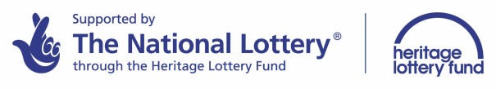
Notes to Editors:
The Greater Game has been made possible thanks to funding from the Heritage Lottery Fund. www.hlf.org.uk.
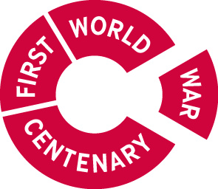

This exhibition forms part of the First World War Centenary Partnership, led by Imperial War Museums. www.1914.org.
The National Football Museum was established and its collection acquired thanks to £9.3m investment by the Heritage Lottery Fund.
The National Football Museum is a registered charity overseen by a board of trustees, and also counts notable names amongst its honorary positions, including Museum President Sir Bobby Charlton, Museum Vice Presidents Sir Alex Ferguson, Sir Trevor Brooking and Sir Geoff Hurst, plus Museum Special Ambassador Mark Lawrenson.
The museum also provides a permanent home for its nationally-recognised Hall of Fame, with new legends being inducted in a prestigious awards ceremony every year.
Entrance is free. To enhance the Museum experience, there are some additional exclusive paid-for interactive exhibits ‘Football Plus+’ to help ensure that visitors enjoy one of the best days out in the city.
Opening Times:
Monday-Saturday 10am – 5pm
Sunday 11am – 5pm
Open Every Day excluding Christmas Eve, Christmas day, Boxing Day, New Year’s Day and Easter Sunday
The venue is fully accessible for wheelchair access
ERDF in the Northwest
The European Regional Development Fund (ERDF) is making a real difference to people and businesses in the North West. With €755 million to invest between 2007 and 2013, ERDF is enhancing the competitiveness of the region’s economy by supporting growth in enterprise and employment.
ERDF in the North West is managed by the Department for Communities and Local Government – for further information visit www.communities.gov.uk/erdf.
Mirrorpix is the Official Image Partner of the National Football Museum
