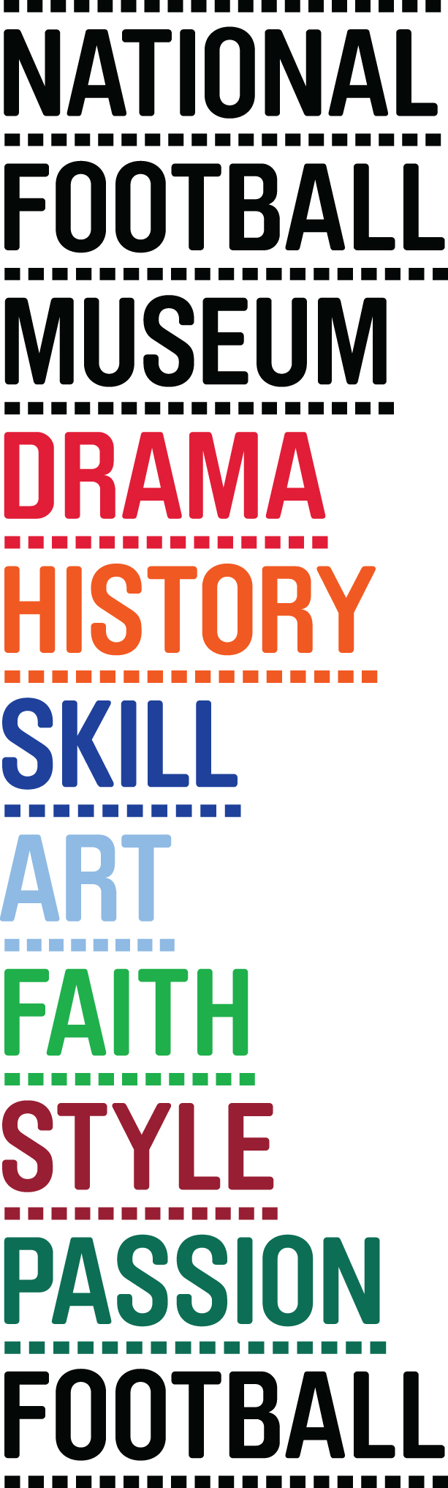
FOOTBALLING LEGENDS INDUCTED INTO HALL OF FAME AT THE NATIONAL FOOTBALL MUSEUM

A HOST OF THE BEAUTIFUL GAME’S HEROES HAVE BEEN INDUCTED INTO THE HALL OF FAME

The National Football Museum has inducted 12 more football legends into its prestigious Hall of Fame at a star-studded ceremony last night.

This year’s inductees include Denis Irwin, who Alex Ferguson regarded pound for pound his greatest ever signing, Liverpool centre half-turned-pundit Mark Lawrenson, and legendary Arsenal and England goalkeeper David Seaman.

Gordon Strachan was inducted for his achievements as a player with Manchester United and Leeds United, along with fellow Scot and Nottingham Forrest alumni John Robertson, who manager Brian Clough once described as the ‘Picasso’ of football.

The honour roll also included Paralympic Great Britain and England Cerebal Palsy player Martin Sinclair; 2006 FA Player of the Year and long-serving Everton left back Rachel Unitt, who has won 102 caps for the England women’s national football team and ex England and Everton goalkeeper Rachel Brown-Finnis.

Legendary ‘one-club’ Liverpool player Billy Liddell received the historians award; with his sons and grandsons attending the event to receive the award from Liverpool and England ’66 winner Ian Callaghan.

Rio Ferdinand, who couldn’t make the ceremony due to prior commitments, but who sent a recorded message, entered the Hall of Fame following his trophy-laden career at Manchester United. The third goalkeeper of the night, Neville Southall, also couldn’t attend, but his award was accepted on his behalf by staunch Evertonian Andy Burnham MP.

The line up was completed with a special award being made to Cambridge University AFC, as the oldest football club in the world

The new inductees have been immortalised next to legends such as Sir Tom Finney, Gordon Banks, Alan Shearer and last year’s inductees Gary Neville and Norman Hunter, whose achievements are already celebrated with a place in the Hall of Fame, a focal point of the museum.

Inductees are chosen by a panel featuring some of the biggest names in football, including the Museum’s President Sir Bobby Charlton, Vice President Sir Alex Ferguson and Gordon Taylor. To qualify for nomination players must have finished their career or be aged over 30 and have played or managed in England for at least five years.

National Football Museum Director Dr. Kevin Moore said: “Once again I can say it’s a privilege to welcome yet more footballing icons to our Hall of Fame. All of this year’s inductees have contributed much to the beautiful game, either on the pitch as a player or in the dugout as a manager.

“As ever, we’re extremely grateful to our main sponsor - the Professional Footballers’ Association, and also to The FA for working with us to deliver the Women’s and Football For All awards. Both organisations have helped us ensure that the Hall of Fame has become one of the most prestigious fixtures in the sporting awards calendar.”

The National Football Museum provides a world-class home for the greatest collection of football memorabilia ever assembled, in addition to housing its nationally recognised Hall of Fame in Manchester.

More than 140,000 objects, works of art and photographs make up this unique collection with over 2,500 on display at any one time. Highlights include its recently launched 1966 World Cup Exhibition, a shirt from the world's first international match played in 1872, and the shirt worn by Maradona during the infamous 1986 ‘Hand of God’ quarter final match between England and Argentina.

Admission is free of charge but, as the museum is a registered charity, it relies on donations from the public and support from the corporate sector.

- Ends -
Media Enquiries: Please contact Brazen PR on 0161 923 4994, or email footballmuseum@brazenpr.com
The National Football Museum was established and its collection acquired thanks to £9.3m investment by the Heritage Lottery Fund.
The National Football Museum is a registered charity overseen by a board of trustees, and also counts notable names amongst its honorary positions, including Museum President Sir Bobby Charlton, Museum Vice Presidents Sir Alex Ferguson, Sir Trevor Brooking and Sir Geoff Hurst, plus Museum Special Ambassador Mark Lawrenson.
The museum also provides a permanent home for its nationally-recognised Hall of Fame, with new legends being inducted in a prestigious awards ceremony every year.
Entrance is free. To enhance the Museum experience, there are some additional exclusive paid-for interactive exhibits ‘Football Plus+’ to help ensure that visitors enjoy one of the best days out in the city.
Opening Times:
Monday-Saturday 10am – 5pm
Sunday 11am – 5pm
Open Every Day excluding Christmas Eve, Christmas Day, Boxing Day and New Year’s Day
The venue is fully accessible for wheelchair access

The National Football Museum is a registered charity overseen by a board of trustees, and also counts notable names amongst its honorary positions, including Museum President Sir Bobby Charlton and Museum Vice President Sir Alex Ferguson.

About the National Museum Hall of Fame

This year’s Hall of Fame is sponsored by the PFA; The FA is supporting the Football for All and Women’s Player awards.

The National Football Museum Hall Of Fame aims to celebrate and highlight the achievements of the all-time top English footballing talents, as well as non-English players and managers who have become significant figures in the history of the English game.

New members are added each year at a special induction ceremony. From 2002 events took place across the country, but since 2013 the annual ceremony takes place at the National Football Museum's Hall of Fame in Manchester.

In 2007, two new categories of induction were established alongside the players, managers and female players' categories. Chiefly, this was in recognition of football's central role in English culture, extending Hall of Fame honours to those whose main contribution to the English game has been outside the more obvious field of play. The Community Champion category – sponsored by the Football Foundation – honours professional players who have donated their spare time and money to the grassroots level of the sport, while the Football for All Award – sponsored by the Football Association – is presented to pioneers of the various forms of football played by disabled people.

Since 2009, the Museum now also commemorates whole teams alongside its awarding of individual players and coaches. The criteria for their induction are that they must have played at least a quarter of a century prior.
The inaugural Selection Panel brought together in 2002 comprised:
Jimmy Armfield
Sir Trevor Brooking (Museum Vice-President)
Jimmy Hill
Mark Lawrenson
Gordon Taylor
In addition, in subsequent years all living inductees into the Hall of Fame automatically join the Selection Panel, so it grows each year, and currently comprises:
Tony Adams, Viv Anderson, Debbie Bampton, Gordon Banks, John Barnes, Peter Beardsley, Colin Bell, Dennis Bergkamp, Liam Brady, Eric Cantona, Jack Charlton, Sir Bobby Charlton (Museum President), David Clarke, Pauline Cope, Matt Dimbylow, Gillian Coulthard, Stephen Daley, Kenny Dalglish, Sir Alex Ferguson (Museum Vice-President), Trevor Francis, Paul Gascoigne, Ryan Giggs, Dario Gradi, Eddie Gray, Jimmy Greaves, Alan Hansen, Glenn Hoddle, Mark Hughes, Roger Hunt, Sir Geoff Hurst, Pat Jennings, Steve Johnson, Cliff Jones, Roy Keane, Kevin Keegan, , Dennis Law, Matthew Le Tissier, Gary Lineker, Sue Lopez, Jimmy Mcilroy, Michael Owen, Sheila Parker Martin Peters, Hope Powell, Niall Quinn, Bryan Robson, Ian Rush, Peter Schmeichel, Alan Shearer, Peter Shilton, Graeme Souness, Nobby Stiles, Mike Summerbee, Terry Venables, Patrick Vieira Karen Walker, Arsene Wenger, Ray Wilson, Ian Wright, Gianfranco Zola. Former Watford, Aston Villa and England manager, Graham Taylor, joined the Panel in 2008.
In 2007 and 2008, eminent football historians joined the panel to advise on players and teams from the early years of the game:
Peter Holme, Prof Dick Holt, Prof John Hughson, Simon Inglis, Dr Alexander Jackson, Prof Graham Kelly, Prof Tony Mason, Gail Newsham, Prof Dave Russell, Prof Matthew Taylor, Prof John Walton and Dr Jean William

