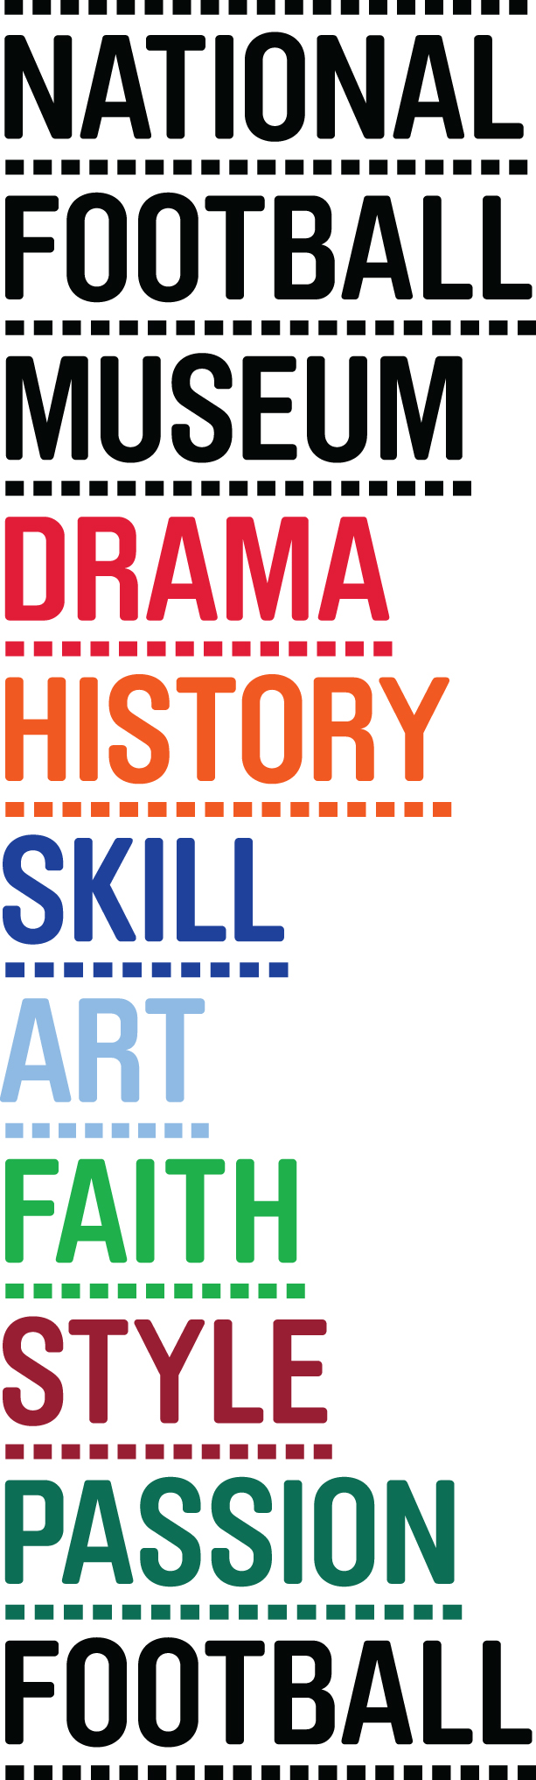
PITCH TO PIXEL: THE WORLD OF FOOTBALL GAMING

NATIONAL FOOTBALL MUSEUM HOSTS WORLD’S FIRST FOOTBALL AND GAMING EXHIBITION

Pitch to Pixel: The World of Football Gaming, the first major exhibition of its kind is set to open at the National Football Museum (NFM) in Manchester on October 23rd.

It will be the first time the relationship between two international obsessions, football and gaming, has been explored in an exhibition as the line between simulation and reality becomes increasingly blurred.

Participatory and provocative, Pitch to Pixel will feature a range of artworks and unique objects alongside interactive gaming experiences and a range of playable classic arcade games.

Objects on display include two bespoke motion capture suits worn by Lionel Messi and Sergio Aguero for EA SPORTS™ FIFA 16; Rio Ferdinand’s Ultimate Team shield from FIFA 15, (torn in two pieces by Ferdinand as he was unhappy with the ratings EA SPORTS gave him) and a 1991 rejection letter to the designers of Football Manager.

A new interactive artwork ‘Hit-it’ by Leo Schatzl will allow visitors to put themselves ‘inside the game’. A ‘header selfie’ will be triggered when a ball is headed, creating a short film of facial expressions taken at a crucial, unguarded moment.

There is also a photo booth where visitors will have the chance to put themselves on the cover of Football Manager, replacing the famously faceless figure that usually appears on the title’s packaging.

A playable timeline of classic games will be available including Pele’s Soccer (Atari), Nintendo World Cup (NES), Sensible Soccer (Amiga) and Go! Go! Beckham (Nintendo Gameboy).

NFM has partnered with two of the biggest players in the football gaming world - EA SPORTS and Sports Interactive, the names behind the hugely popular football franchises FIFA and Football Manager, to provide expertise for the exhibition, with support from Arts Council England.

Curator John O’Shea commented “In its four decade history the computer games industry has successfully imitated, replicated and simulated much of what makes football such a fascinating game to play and to watch. Football and gaming now overlaps to such a degree that it’s sometimes difficult to see where one ends and the other begins.

NFM Director Kevin Moore said: “A major exhibition, focusing on football and computer gaming has never been done before. We’re delighted that, thanks to our funder and partners, we are able to realise our ambition of bringing football, digital culture and participation in the arts together.

Alison Clark, Director North, Arts Council England said: '‘The Arts Council is delighted to support this exciting show that brings together footballing, gaming and art. Each is an important aspect of contemporary culture – no more so than here in Manchester – and the creative interplay between them will form a fantastic cultural experience for a very wide audience."

James Salmon, UK Product Marketing Manager for EA SPORTS FIFA commented: “We’re incredibly excited to be part of this exhibition at the home of football memorabilia. It’s great that the history of football games is being recognised as we see the lines between the console and pitch becoming increasingly blurred.

Miles Jacobson, Studio Director at Sports Interactive, manufacturers of Football Manager said: "When Ov and Paul Collyer made our first game in their bedrooms, they weren’t even thinking of it being seen by anyone but their friends. Now, 22 years later, Football Manager is not only played by millions of people round the world, but it's also used by real life football clubs and media as a scouting and research tool, transcending its humble roots to being an integral part of football.

“We’re delighted that the National Football Museum has recognised the influence that football video games have had on wider football culture and are incredibly proud to be part of this new exhibition."

Ends

Press are invited to a preview of the exhibition on Wednesday 21 October from 8am onwards. For further information contact Joe on 0161 923 4994 or email on

footballmuseum@brazenpr.com.






THE NATIONAL FOOTBALL MUSEUM
The National Football Museum was established and its collection acquired thanks to £9.3m investment by the Heritage Lottery Fund.
The National Football Museum is a registered charity overseen by a board of trustees, and also counts notable names amongst its honorary positions, including Museum President Sir Bobby Charlton, Museum Vice Presidents Sir Alex Ferguson, Sir Trevor Brooking and Sir Geoff Hurst, plus Museum Special Ambassador Mark Lawrenson.
The museum also provides a permanent home for its nationally-recognised Hall of Fame, with new legends being inducted in a prestigious awards ceremony every year.
Entrance is free. To enhance the Museum experience, there are some additional exclusive paid-for interactive exhibits ‘Football Plus+’ to help ensure that visitors enjoy one of the best days out in the city.
Opening Times:
Monday-Sunday 10am – 5pm
Open Every Day excluding Christmas Eve, Christmas day, Boxing Day and New Year’s Day
The venue is fully accessible for wheelchair access
www.nationalfootballmuseum.com
ARTS COUNCIL
Arts Council England champions, develops and invests in artistic and cultural experiences that enrich people’s lives. We support a range of activities across the arts, museums and libraries – from theatre to digital art, reading to dance, music to literature, and crafts to collections. Great art and culture inspires us, brings us together and teaches us about ourselves and the world around us. In short, it makes life better. Between 2015 and 2018, we plan to invest £1.1 billion of public money from government and an estimated £700 million from the National Lottery to help create these experiences for as many people as possible across the country. www.artscouncil.org.uk

SPORTS INTERACTIVE LTD.
Sports Interactive (SI) is the world’s leading developer of football management simulations through its Football Manager series. Founded in 1994 and based in the Old Street area of London, SI has a full-time staff of more than 100 and employs the services of roughly 1,300 part-time researchers across the globe (alongside more than 200 offsite Beta testers). SI has ongoing relationships with some of the biggest names in professional football, including Prozone, the League Managers Association, The Football League, La Liga and many other leagues and national associations. SI became a wholly-owned subsidiary of SEGA in 2006. Further information on the company and its games is available at www.sigames.com.






