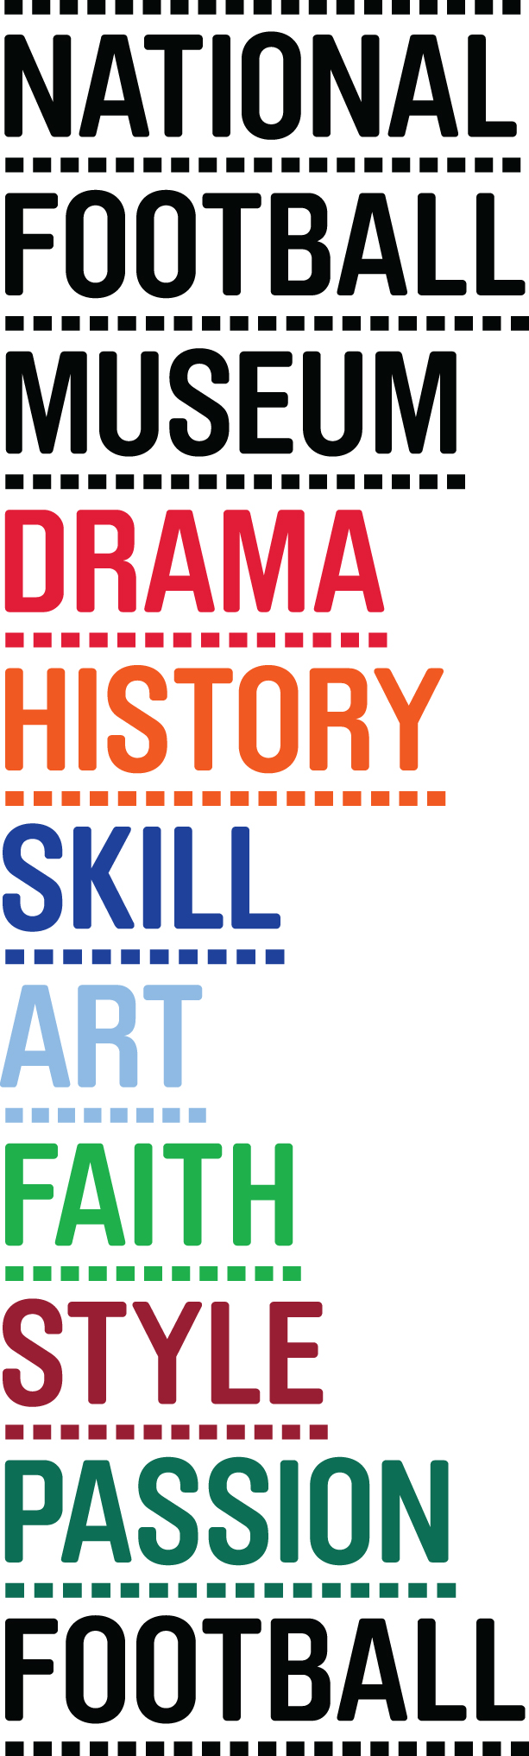
PITCH TO PIXEL: THE WORLD OF FOOTBALL GAMING

NATIONAL FOOTBALL MUSEUM HOSTS WORLD’S FIRST FOOTBALL AND GAMING EXHIBITION

Pitch to Pixel: The World of Football Gaming, the first major exhibition of its kind is set to open at the National Football Museum (NFM) in Manchester on October 23rd.

It will be the first time the relationship between two international obsessions, football and gaming, has been explored in an exhibition as the line between simulation and reality becomes increasingly blurred.

Participatory and provocative, Pitch to Pixel will feature a range of artworks and unique objects alongside interactive gaming experiences and a range of playable classic arcade games.

NFM has partnered with two of the biggest players in the football gaming world - EA SPORTS and Sports Interactive, the names behind the hugely popular football franchises FIFA and Football Manager, to provide expertise for the exhibition, with support from Arts Council England.

Ends

For further information or to attend the press preview please contact Joe or Jess on 0161 923 4994 or email on

footballmuseum@brazenpr.com.

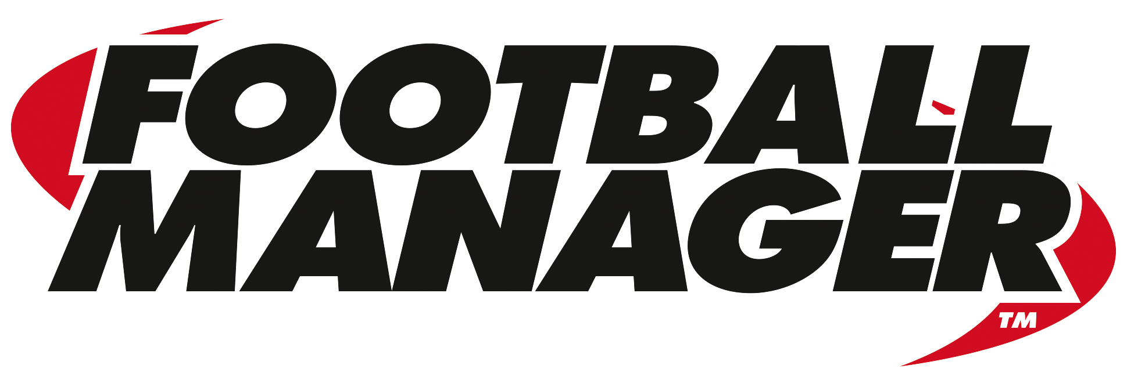
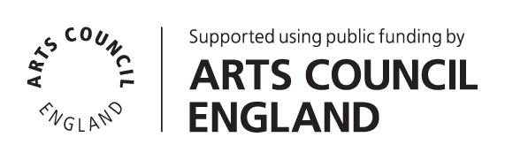

THE NATIONAL FOOTBALL MUSEUM
The National Football Museum was established and its collection acquired thanks to £9.3m investment by the Heritage Lottery Fund.
The National Football Museum is a registered charity overseen by a board of trustees, and also counts notable names amongst its honorary positions, including Museum President Sir Bobby Charlton, Museum Vice Presidents Sir Alex Ferguson, Sir Trevor Brooking and Sir Geoff Hurst, plus Museum Special Ambassador Mark Lawrenson.
The museum also provides a permanent home for its nationally-recognised Hall of Fame, with new legends being inducted in a prestigious awards ceremony every year.
Entrance is free. To enhance the Museum experience, there are some additional exclusive paid-for interactive exhibits ‘Football Plus+’ to help ensure that visitors enjoy one of the best days out in the city.
Opening Times:
Monday-Sunday 10am – 5pm
Open Every Day excluding Christmas Eve, Christmas day, Boxing Day and New Year’s Day
The venue is fully accessible for wheelchair access
www.nationalfootballmuseum.com
ARTS COUNCIL
Arts Council England champions, develops and invests in artistic and cultural experiences that enrich people’s lives. We support a range of activities across the arts, museums and libraries – from theatre to digital art, reading to dance, music to literature, and crafts to collections. Great art and culture inspires us, brings us together and teaches us about ourselves and the world around us. In short, it makes life better. Between 2015 and 2018, we plan to invest £1.1 billion of public money from government and an estimated £700 million from the National Lottery to help create these experiences for as many people as possible across the country. www.artscouncil.org.uk

SPORTS INTERACTIVE LTD.
Sports Interactive (SI) is the world’s leading developer of football management simulations through its Football Manager series. Founded in 1994 and based in the Old Street area of London, SI has a full-time staff of more than 100 and employs the services of roughly 1,300 part-time researchers across the globe (alongside more than 200 offsite Beta testers). SI has ongoing relationships with some of the biggest names in professional football, including Prozone, the League Managers Association, The Football League, La Liga and many other leagues and national associations. SI became a wholly-owned subsidiary of SEGA in 2006. Further information on the company and its games is available at www.sigames.com.




