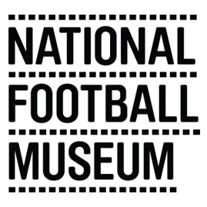

VOLUNTEER APPLICATION FORM
Please type or use black ink to complete this form as it may be photocopied.
All information will be treated as confidential

What volunteering opportunity are you applying for?

PERSONAL DETAILS
First Name(s) Last Name

Home Address Contact Address (if different)
Post Code: | Post Code

Telephone Number (home) Telephone Number (mobile)

Email Address

VOLUNTEER OPPORTUNITY

Please give details of any skills or interests you have which you feel may be relevant to your application (previous work or volunteering experience, training etc.)

In order to help us ensure your safety whilst volunteering with us, please provide details of any health issues which you feel we should be aware of

How did you find out about this position?

When would you like to volunteer?
 | Monday | Tuesday | Wednesday | Thursday | Friday | Saturday | Sunday
AM
PM

I declare that the information I have given is true to the best of my knowledge.

Signed……………………………………………………………………………………

Date ……………………………………………………………………………………..

PLEASE RETURN COMPLETED FORMS TO:
Darren Collingwood – Volunteer & Participation Manager
National Football Museum, Urbis Building, Cathedral Gardens, Manchester M4 3BG or email to volunteering@nationalfootballmuseum.com.

EQUAL OPPORTUNITIES MONITORING
The National Football Museum is committed to ensuring that there is no discrimination on the grounds of race, sex, age, disability, sexual orientation or marital status, either in access to employment or in employment practices.

To help us monitor the effectiveness of our Equal Opportunities Policy, please complete the appropriate details below. Your co-operation will greatly help us to promote equality of opportunity. This information will be used for monitoring purposes only and will be treated as strictly confidential.

Gender:

Date of Birth:

Nationality:

Ethnic Group (please tick)
White British  White Other (please specify)  Black British  Black Caribbean  Black African  Black Other (please specify) | Indian  Pakistani  Bangladeshi  Chinese  Other Ethnic Group (please describe)  Prefer not to say

Do you have a disability?
Yes No

The National Football Museum value the diverse nature of their staff, volunteers and visitors. We welcome applicants with all range of abilities and are committed to providing a positive environment. So, we can best support you, please provide us with details of any disabilities or health issues:

Please specify if you have any additional requirements that would enable you to attend an informal meeting:

