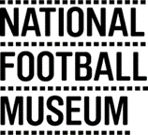

Visual Artist Opportunity at the National Football Museum
The National Football Museum opened in the Urbis building in Manchester in 2012. We hold the world’s largest collection of objects about the history of football and football culture and our social purpose is to explore how football is the game of our lives. We aim to promote equal access to share and enjoy stories about football. Our current audience is mostly made up of adults, families, international visitors and groups visiting Manchester to watch football. We would like to encourage more visits by young people, women, girls, local families and the LGBTQ+ community.
The project
The National Football Museum has been awarded funding from the AIM (Association of Independent Museums) History-Makers scheme to re-develop part of our gallery to tell the story of footballer Lily Parr. Lily played from 1917 to the early 1950s, spending most of her career with influential team the Dick, Kerr Ladies, one of the most successful of the World War One munitions teams. The AIM History Makers scheme celebrates 20th Century individuals who have helped to shape our world.
The Museum has made a commitment to increase its representation of women in football to 50% across its collections and exhibitions and this project will be a key part of that. The centre piece of the new gallery will be a life-size bronze statue of Lily Parr, sculpted by Hannah Stewart and installed at the National Football Museum last year.
The gallery will also feature a new audio-visual presentation of Lily’s story and a selection of objects from the Museum’s women’s football collection that have not been previously displayed. One of the challenges is that there is very little footage or images of Lily available and so we want the new display to tell her story in a dynamic, engaging and inspirational way with a contemporary look and feel to emphasise her role as a pioneer. We will also use our terrace banner space to celebrate Lily and encourage visitors to see the new gallery. The banners were introduced to the Museum in 2019 and have been primarily slogan driven in the same way that you often see banners in a football stadium. Please see images of existing and previous terrace banner projects at NFM attached. The new space is currently scheduled to open in Spring 2021.
We would like to commission an artist/s to deliver some of the creative elements of the project and run community art activities once the Museum is re-opened to the public in line with government guidelines.
These include:
- An artistic interpretation of Lily’s story to displayed alongside Lily Parr’s statue
- Production and design of a series of terrace banners to interpret Lily’s story
- Delivering a series of community engagement workshops that will contribute to the final design of the terrace banner series. We would like to attract young people and particularly young women and girls and LGBTQ+ young people to these workshops. The number of workshops will be decided in partnership with the artist.
Timescale
Provisional timescale
August 2020 to January 2021
Budget
- Design of statue interpretation - £2,000
- Fee for community art workshops - £3,000
- Design of terrace banners - £1,500
How to submit proposals
Please send your proposal about how you would interpret this brief including examples of your previous work to Belinda Scarlett at belinda.scarlett@nationalfootballmuseum.com by 14th August. Please indicate in your submission if you would like to submit a proposal for one or both artistic elements of the project.
Contact
If you would like to talk through this brief or your proposal before submission, please contact Belinda Scarlett on belinda.scarlett@nationalfootballmuseum.com or 07764 745571
Lily Parr statue on display at the museum
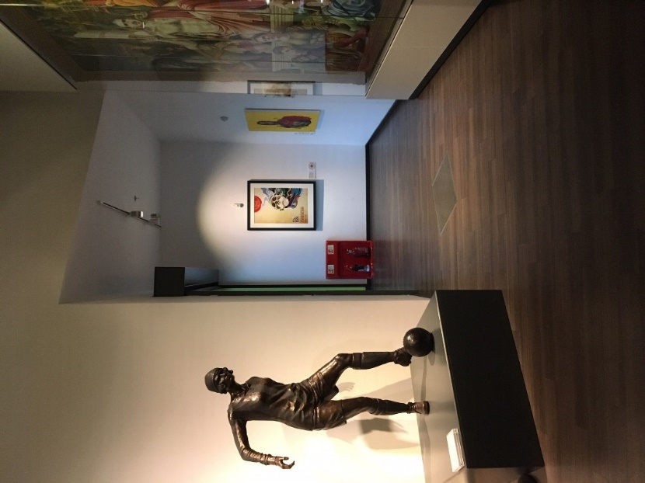

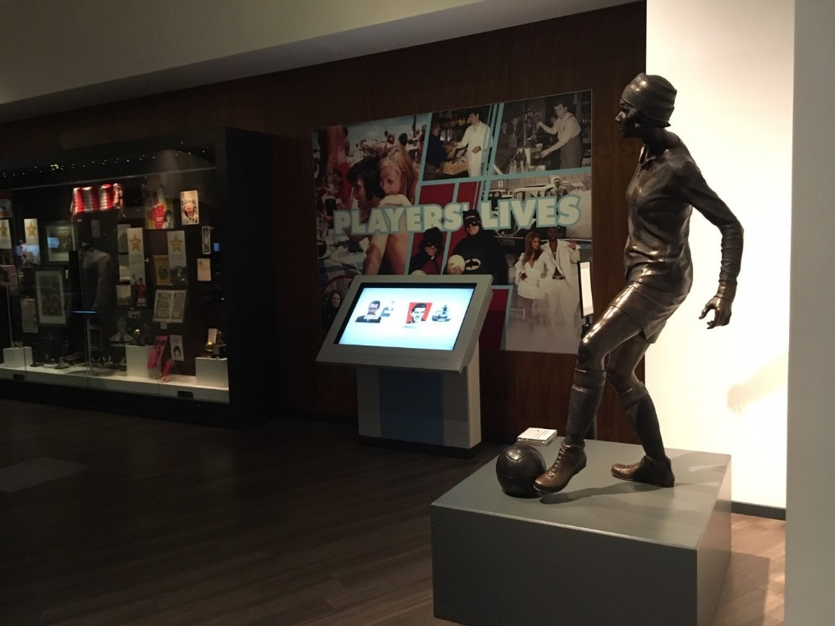

Banners on display in the entrance area of the National Football Museum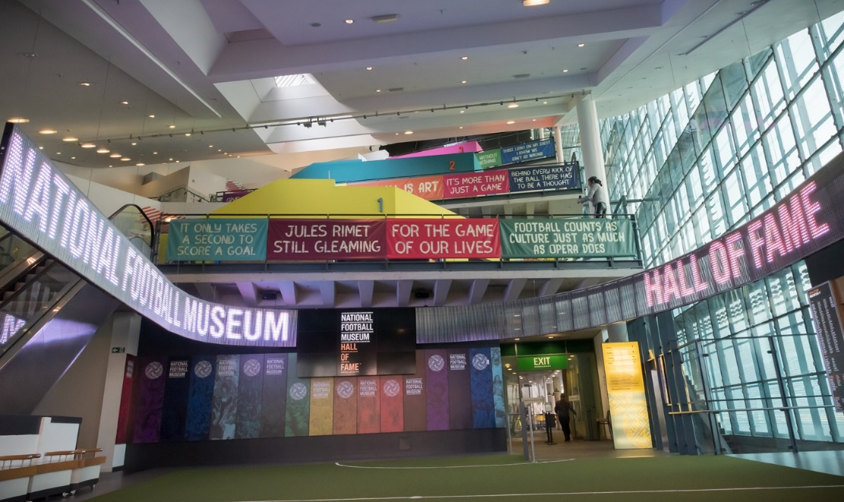
More images of the museum and our collection are available on request.

