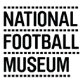

Curatorial Coordinator (Documentation and Resource Centre) Application Pack

About

As England’s national museum for football we explore the impact of football as the game of all our lives and how it shapes our identities. We want to be known as a leading national museum engaging visitors in the museum and digitally, and by visiting our local communities and schools.

The Museum opened in Preston in 2001 and moved to Manchester in 2012 with support from Manchester City Council. Drawing on a collection of over 40,000 objects including The FA Collection, the museum delivers community and public programmes and activities across four floors of gallery space and online. NFM aims to portray all aspects of football and reflect the material culture of football. The collections cover the experiences of clubs, players, officials, supporters and all concerned with the game at different levels, from grassroots to the elite game.

NFM has what is widely considered to be the world’s finest collections relating to the football history, art, design and photography. The collection numbers over 40,000 objects relating to football and the social history of the game and includes programmes, fanzines, trophies, equipment, art, photography and film, oral history and objects relating to fan culture, behaviour and activism.

To fulfil our role within the game the Museum as part of the Strategic Plan is setting out to establish a Football Heritage Collection (FHC) which is curated by the museum on behalf of the key football authorities as well as people involved in the game.

At the heart of future collecting will be the social impact of the national game. This will include a focus on collecting material to reflect contemporary football, and contemporary fan culture. Collecting will also focus on representation and diversity of the game at all levels.

We are committed to increasing representation of women’s involvement in football to 50% of our onsite and online content. We have made great strides in increasing our women’s football collection, developing links with women’s teams, and delivering activities and programming that engage the public with past and present women’s football. We are excited about the upcoming Women’s EURO 2022, which will be hosted in cities across England, including in Manchester, and we have lots planned to ensure we collect this important football history as it happens.

Mission

Sharing stories about football

We’re the place for everyone to enjoy stories about football culture. It’s our mission to hear those stories and tell them in an engaging and creative way.

Values

Creative & Inspiring: Using our imaginations to enthuse all of our visitors
Authentic & Honest: Telling real stories with integrity
Inclusive & Respectful: Being friendly & approachable
Passionate & Fun: Instilling passion and enjoyment for football

About the Team

Your role will sit in NFM’s Content team, which has responsibility for collections, exhibitions and informal and formal learning at the Museum. The Content team is responsible for the delivery of two of the four strategic aims of the Museum:

Aim 1: Become a centre of excellence for football heritage through fully representative exhibitions, collections and research.

Aim 2: Build an award winning and inclusive programme of community and public engagement activities.

It’s our job to collect and preserve fascinating objects that tell diverse stories of football past and present, create permanent and temporary exhibitions for a wide range of audiences, and deliver engaging programmes and activities for schools, community groups and the wider public.

You will work day-to-day with the Collections team, carrying out a wide variety of tasks that support collections development, research enquiries, and collections management. You will also support the wider Content Team to ensure the collection is widely accessible to the public via exhibitions, displays, digital content, and public programming.

You will join a Collections team of 5 members of staff:

- Collections Manager
- Curators (2 x FTE; 1 x 0.2 FTE)
- Curatorial Coordinator (Documentation and Resource Centre)

The team also regularly works with volunteers who support us in many aspects of our work.

As an employer, the National Football Museum is committed to equality. We value diversity and the role it plays in a positive workplace culture. We are especially keen to hear from applicants who identify as working-class, Black, Asian or ethnically diverse, and / or disabled, since these groups are significantly underrepresented in the museums sector.
We recognise there are many different career experiences and skill sets that could suit this role. We are open to applications from people who feel they could deliver the Job Description, even if this role would be a bit different from their past experience and / or they don’t quite fit the person specification below. If this is you, we welcome your application; please make sure to illustrate in your application how you think your qualities, skills and experiences would enable you to carry out the Job Description effectively.

Thanks for reading! We hope you’re interested in joining the team.

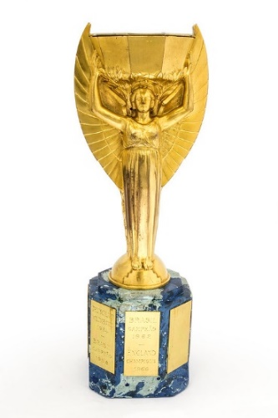
A look at some of our collection
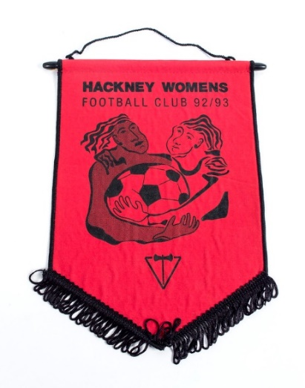
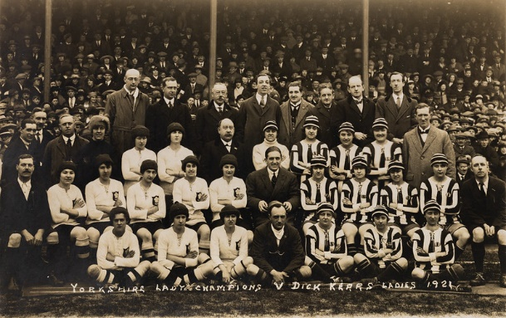

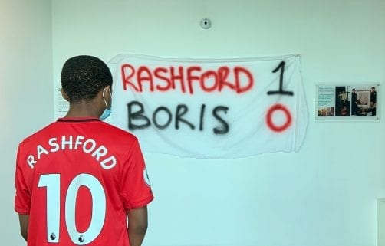
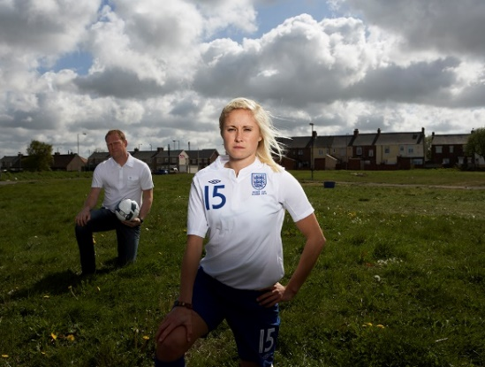

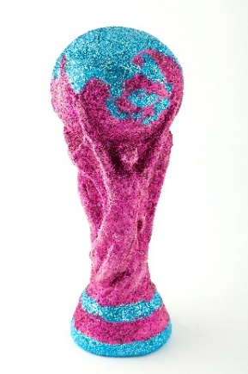
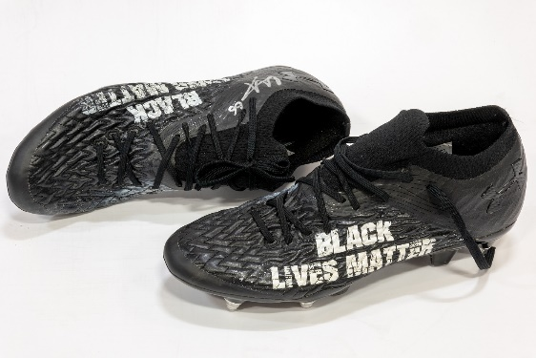

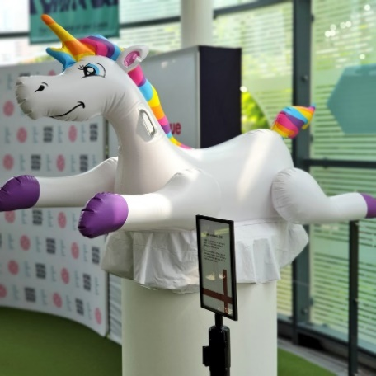

Some of the objects in our collection, including recent acquisitions: From top-bottom, left-right:
Jules Rimet World Cup trophy, 1966
Hackney Women's FC Pennant, 1992
Postcard of Yorkshire Ladies v. Dick Kerr's Ladies, 19 March 1921
Portrait of Steph Houghton by Alison Palmer, 2005
Rashford 1 – 0 Boris banner, 2020
Trent Alexander-Arnold Black Lives Matter boots, 2020
The Justin Fashanu Cup, 2012
Leeds United player-worn T-shirt protesting the European Super League, 2021
Unicorn from St. George’s Park, 2021

Job Description and Person Specification

Department: Collections
Job Title: Curatorial Coordinator (Documentation and Resource Centre)
Reports to: Collections Manager
Responsible for: Volunteers, project and placement posts as required

This full-time role is a split-site role between the museum’s Resource Centre in Preston and the National Football Museum in Manchester, with predominantly three days at Preston and two days at Manchester.
Outcomes: High standards of documentation and collections management, progress of Documentation Plan and reduction of backlog, increased public access to the Museum’s Resource Centre
JOB PURPOSE
- To assist with collections management, research, enquiries and documentation
- To assist with the management of the collections database under the guidance of the Collections Manager
- To prepare objects for display and assist with installation in main galleries (Manchester)
- To carry out inventory control of displays
- To lead and assist with public engagement activities that communicate the collection to a range of audiences
- To develop and maintain an expert knowledge of the collection and subject matter

KEY RESPONSIBILITIES
Collections & Collections Management
- To carry out documentation and feed into the standardisation of the collections database
- To Accession, document and store new objects
- To process loans in and out: Loan administration, object condition checking, conservation and return of loans
- To arrange the digitisation of the collection and adding to collections online
- To implement the museum’s Documentation Plan including Retrospective Documentation
- To carry out store management at Manchester and the logistics of transfer of objects between Manchester and Preston sites
- To carry out a programme of environmental monitoring of stores and galleries at Preston and Manchester
- To assist the Collections Manager with policies, plans and procedures as required by ACE Accreditation
- To assist with store management as directed by the Collections Manager
- To assist the curatorial team with active collecting and disposal
Enquiries & Images
- To be the first point of contact for research and collections enquiries, including image enquiries
- To keep an up-to-date log of public enquiries
- To work on improvements to the museum’s image database
- To liaise with picture libraries and adding to the Museum’s image stock
- To deal with image enquiries, provision and sale of images
- To manage day-to-day collections correspondence with lenders and donors, monitoring incoming enquiries and distribution to relevant members of staff

Public Engagement & Access
- To promote the Resource Centre to interested parties and to book research and group visits to the Centre
- To lead and assist with public engagement activities that enable a range of audiences to access and learn more about the collections at the Resource Centre
- To assist with research or drafting display text
- To assist with exhibition changeovers, gallery updates and installation of objects
- To carry out object handling training for staff and volunteers
- To recruit and manage a small team of volunteers to support collections management, documentation and public engagement activities at the Resource Centre
- To assist the Buildings team with service visits and appointments to the Resource Centre
- To disseminate research and stories about collections through digital content, including blogs and social media content
General
- To take positive action to promote Equal Opportunities and diversity in all aspects of the work of the NFM
- To agree to abide by NFM policies, such as Health & Safety, Child Protection etc.
- To maximise income and minimise expenditure wherever possible
- To carry out such other duties as may be reasonably expected of the post

Person Specification
Essential Experience
- Experience of working with collections in a paid and/or unpaid capacity
- Collection databases and documentation procedures
Essential Knowledge and Skills
- Effective team player
- Excellent interpersonal and oral and written communication skills
- Sound judgement and effective decision-making skills
- Excellent attention to detail
- Self-starting, positive and enthusiastic, with the ability to work effectively independently
- Excellent organisation and time management skills
- IT skills including spreadsheets, databases and electronic imaging
- Ability to communicate the significance of collections to non-specialist audiences
- Willingness to develop and maintain an expert knowledge in football heritage and football culture
Desirable
- Good understanding of Collections Management and curatorial standards
- Good understanding of manipulating, storing and accessing digital images

Application Information

How to apply

Please send the following to Wiebke Cullen, Collections Manager, on wiebke.cullen@nationalfootballmuseum.com

- Your CV
- A cover letter setting out why you would like the role and showing how your skills and experience match what we’re looking for
- Contact details of two references and their relationship to you
- A completed equal opportunities monitoring form (available to download here: https://www.nationalfootballmuseum.com/jobs/).
- A statement of no more than 500 words showing your understanding of and commitment to the values of the National Football Museum: https://www.nationalfootballmuseum.com/mission-vision/

Interviews: 9th March
Interviews will be held at the National Football Museum in Manchester, COVID-19 restrictions permitting. If we cannot hold interviews at the Museum, they will be held over Zoom.

