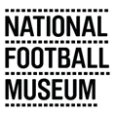

Curator Application Pack

About

As England’s national museum for football we explore the impact of football as the game of all our lives and how it shapes our identities. We want to be known as a leading national museum engaging visitors in the museum and digitally, and by visiting our local communities and schools.

The Museum opened in Preston in 2001 and moved to Manchester in 2012 with support from Manchester City Council. Drawing on a collection of over 40,000 objects including The FA Collection, the museum delivers community and public programmes and activities across four floors of gallery space and online. NFM aims to portray all aspects of football and reflect the material culture of football. The collections cover the experiences of clubs, players, officials, supporters and all concerned with the game at different levels, from grassroots to the elite game.

NFM has what is widely considered to be the world’s finest collections relating to the football history, art, design and photography. The collection numbers over 40,000 objects relating to football and the social history of the game and includes programmes, fanzines, trophies, equipment, art, photography and film, oral history and objects relating to fan culture, behaviour and activism.

To fulfil our role within the game, as part of the Museum’s Strategic Plan, we are setting out to establish a Football Heritage Collection (FHC) which is curated by the Museum on behalf of the key football authorities as well as people involved in the game.

At the heart of future collecting will be the social impact of the national game. This will include a focus on collecting material to reflect contemporary football, and contemporary fan culture. Collecting will also focus on representation and diversity of the game at all levels.

We are committed to increasing representation of women’s involvement in football to 50% of our onsite and online content. We have made great strides in increasing our women’s football collection, developing links with women’s teams, and delivering activities and programming that engage the public with past and present women’s football. We are excited about the upcoming Women’s EURO 2022, which will be hosted in cities across England, including in Manchester, and we have lots planned to ensure we collect this important football history as it happens.

Mission

Sharing stories about football

We’re the place for everyone to enjoy stories about football culture. It’s our mission to hear those stories and tell them in an engaging and creative way.

Values

Creative & Inspiring: Using our imaginations to enthuse all of our visitors
Authentic & Honest: Telling real stories with integrity
Inclusive & Respectful: Being friendly & approachable
Passionate & Fun: Instilling passion and enjoyment for football

About the Team

Your role will sit in NFM’s Content team, which has responsibility for collections, exhibitions and informal and formal learning at the Museum. The Content team is responsible for the delivery of two of the four strategic aims of the Museum:

Aim 1: Become a centre of excellence for football heritage through fully representative exhibitions, collections and research.

Aim 2: Build an award winning and inclusive programme of community and public engagement activities.

It’s our job to collect and preserve fascinating objects that tell diverse stories of football past and present, create permanent and temporary exhibitions for a wide range of audiences, and deliver engaging programmes and activities for schools, community groups and the wider public.

You will work day-to-day with the Collections team, carrying out a wide variety of tasks that support collections development, research enquiries, and collections management. You will also support the wider Content Team to ensure the collection is widely accessible to the public via exhibitions, displays, digital content, and public programming.

You will join a Collections team of 5 members of staff:

- Collections Manager
- Curators (2 x FTE; 1 x 0.2 FTE)
- Curatorial Coordinator (Documentation and Resource Centre)

The team also regularly works with volunteers who support us in many aspects of our work.

As an employer, the National Football Museum is committed to equality. We value diversity and the role it plays in a positive workplace culture. We are especially keen to hear from applicants who identify as working-class, Black, Asian or ethnically diverse, and/or disabled, since these groups are significantly underrepresented in the museums sector.
We recognise there are many different career experiences and skill sets that could suit this role. We are open to applications from people who feel they could deliver the Job Description, even if this role would be a bit different from their past experience and/or they don’t quite fit the person specification below. If this is you, we welcome your application; please make sure to illustrate in your application how you think your qualities, skills and experiences would enable you to carry out the Job Description effectively.

Thanks for reading! We hope you’re interested in joining the team.

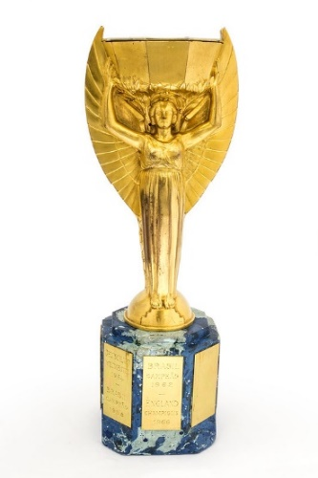
A look at some of our collection
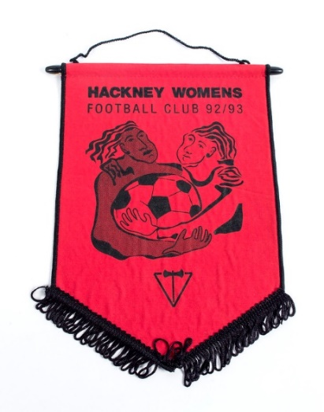
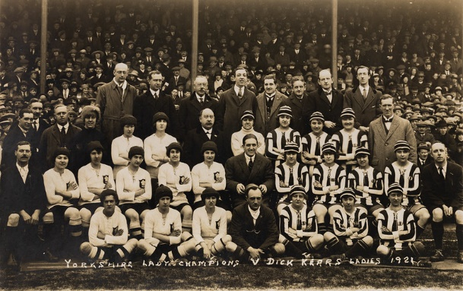

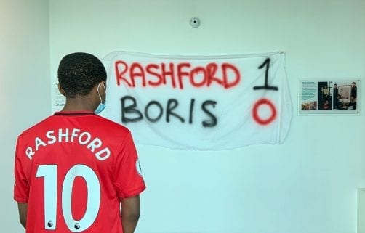
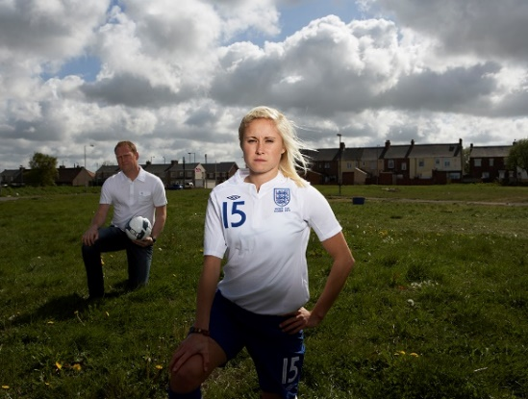

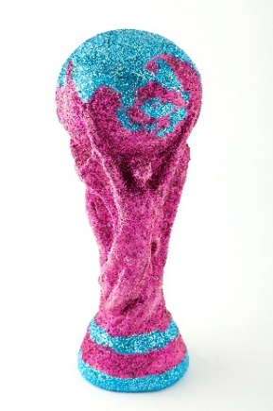
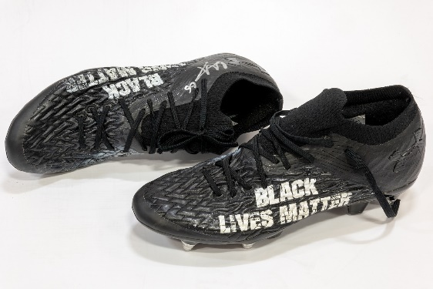

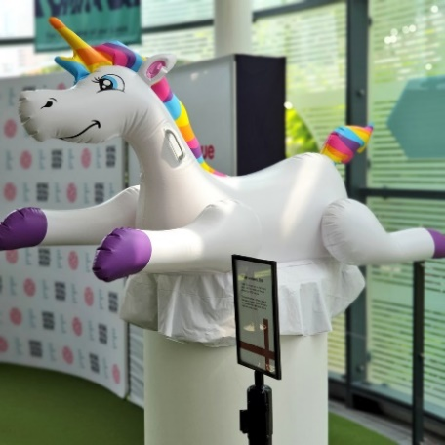
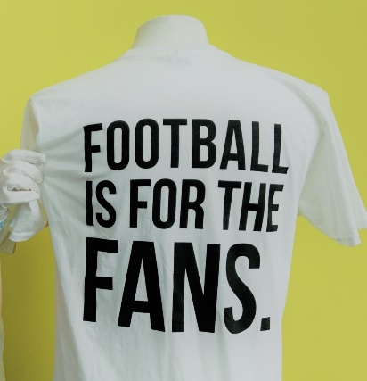

Some of the objects in our collection, including recent acquisitions: From top-bottom, left-right:
Jules Rimet World Cup trophy, 1966
Hackney Women's FC Pennant, 1992
Postcard of Yorkshire Ladies v. Dick Kerr's Ladies, 19 March 1921
Portrait of Steph Houghton by Alison Palmer, 2005
Rashford 1 – 0 Boris banner, 2020
Trent Alexander-Arnold Black Lives Matter boots, 2020
The Justin Fashanu Cup, 2012
Leeds United player-worn T-shirt protesting the European Super League, 2021
Unicorn from St. George’s Park, 2021

Job Description and Person Specification

Department: Collections
Job Title: Curator
Reports to: Collections Manager
Responsible for: Volunteers, project and placement posts as required
Outcomes: Development of a nationally important, representative collection; research activity; publications; public programme
The job is predominantly based at the National Football Museum in Manchester, with approximately one day a week working at the Museum’s Resource Centre in Preston.

JOB PURPOSE
- To develop the museum’s collections
- To carry out and disseminate research about the museum’s collection, focused on the women’s game
- To increase the museum’s research profile and support NFM in building strategic relationships, including across the football and museum sectors
- To meet the public’s need to access the collections through interpretation, enquiries and public programming

KEY RESPONSIBILITIES
Collections & Collections Management
- To develop the collection according to the Collections Development Policy and in conjunction with an Advisory Panel
- To feed into and carry out the museum’s Contemporary Collecting Strategy
- To develop and maintain relationships with local football communities (e.g. teams, fans) to support contemporary collecting
- To assist with Accessioning of new objects and updating of the collections database with research findings
- To identify loans into the collection for display and special exhibitions
- To support store management and potential future store moves as directed by the Collections Manager
- To manage additional projects for the development of the collection as required
Research
- To carry out research into areas of the collection and football history as required by the museum’s strategic plan and exhibitions programme
- To respond to enquiries as the subject specialist
- To manage research appointments at the museum’s Research Centre in Preston in conjunction with other Curators
- To assist the Curatorial Coordinator with image enquiries
- To assist with identifying funding requirements and potential funding sources as well as feed into grant and project applications
- To be the subject specialist for the NFM’s Hall of Fame
- To keep abreast of contemporary issues and developments in the game
Exhibitions & Public Programme

- To carry out research and writing display text as directed by the strategic plan and under the guidance of the Head of Content
- To have significant input into exhibitions that have a link to the NFM collection under the guidance of the Head of Content
- To carry out image research
- To assist with exhibition changeovers, gallery updates and installation of objects
- To lead on giving talks and tours on the collection at both sites as well as online as required
- To feed into other activities such as trails and tour scripts as required

Publications

- To lead on disseminating research findings through regular blogs, magazine/newspaper articles and other publications and giving papers at selected conferences
- To regularly feed research into Social Media stories by Marketing department
- To support online exhibitions and digital learning videos in conjunction with the Digital Producer and Community team
General
- To take positive action to promote Equal Opportunities and diversity in all aspects of the work of the NFM
- To agree to abide by NFM policies, such as Health & Safety, Child Protection etc.
- To maximise income and minimise expenditure wherever possible
- To carry out such other duties as may be reasonably expected of the post

Person Specification
Experience
- Experience of working with collections in a paid and/or unpaid capacity
- Working with volunteers
- Preparation of exhibitions and/or publications
- Research activity in a related subject
- Collection databases and documentation procedures
- Working with external partners and/or research networks
- Delivering public engagement activities that engage people with collections
Essential Knowledge and Skills
- Effective team player
- Excellent interpersonal and communication skills
- Sound judgement and effective decision-making skills
- Drive and determination to achieve results
- Self-starting, positive, enthusiastic and energetic with good time management skills
- IT skills including spreadsheets, databases and electronic imaging
- Good understanding of collections management and conservation issues
- Ability to interpret collections and work with other departments on exhibition planning
Desirable
- Interest in contemporary issues in football e.g. politics in sport, equality and diversity
- Project management

Application Information

How to apply

Please send the following to Wiebke Cullen, Collections Manager, on wiebke.cullen@nationalfootballmuseum.com

- Your CV
- A cover letter setting out why you would like the role and showing how your skills and experience match what we’re looking for
- A statement of no more than 500 words showing your understanding of and commitment to the values of the National Football Museum: https://www.nationalfootballmuseum.com/mission-vision/
- Contact details of two references and their relationship to you
- A completed equal opportunities monitoring form (available to download here: https://www.nationalfootballmuseum.com/jobs/).

Deadline for submission of applications: 13 February 2022

Interviews: 2 March 2022. Interviews will be held at the National Football Museum in Manchester, COVID-19 restrictions permitting. If we cannot hold interviews at the Museum, they will be held over Zoom.

End of Document.

